**Questions For Investigation**

1. What is our independent variable? What is our dependent variable?
   1. The independent variable is the words condition (congruent / incongruent).
   2. The dependent variable is the time it takes to name the ink colors.
2. What is an appropriate set of hypotheses for this task? What kind of statistical test do you expect to perform? Justify your choices.
   1. H0: μC - μI = 0
      1. Null Hypothesis: The population mean for the Incongruent word condition is the same as the population mean for the Congruent word condition.
      2. Definitions:
         1. H0: Null Hypothesis
         2. μC: Population Mean of Congruent Word Condition
         3. μI: Population Mean of Incongruent Word Condition
      3. Justification: The null hypothesis should state that there is no change.
   2. HA: μC - μI < 0
      1. Alternate Hypothesis: The population mean for the Incongruent word condition is larger than the population mean for the Congruent word condition. Definitions:
         1. HA: Alternate Hypothesis
         2. μC: Population Mean of Congruent Word Condition
         3. μI: Population Mean of Incongruent Word Condition
      2. Justification: This alternate hypothesis is appropriate since I want to know if it took longer for participants to name the ink colors with the Incongruent word condition versus the Congruent word condition.
   3. I will perform a one-tailed, dependent t-test for paired samples in the negative (-) direction to determine if the null hypothesis will be accepted or rejected.
      1. Assumptions:
         1. We have less than 30 paired samples. (24 paired samples)
         2. We don’t know the population's standard deviation.
         3. The distribution is normal (Gaussian).
      2. Justification: There are less than 30 paired samples and we do not know the populations’ standard deviation, so I will perform a t-test. This will be a dependent t-test, since one sample has been tested twice. The t-test will be performed in the negative (-) direction to determine if participants took longer to name the ink colors with the incongruent word condition versus the congruent word condition. A 95% confidence level and t-critical value of -1.714 will be used to determine if the null hypothesis should be accepted or rejected.

Now it’s your chance to try out the Stroop task for yourself. Go to [this link](https://www.google.com/url?q=https://faculty.washington.edu/chudler/java/ready.html&sa=D&ust=1452645040310000&usg=AFQjCNFZ-cV8yL8k-3IlFq8q2TGHdRnkvQ), which has a Java-based applet for performing the Stroop task. Record the times that you received on the task (you do not need to submit your times to the site.) My times (10.125, 17.772). Now, download [this dataset](https://www.google.com/url?q=https://drive.google.com/file/d/0B9Yf01UaIbUgQXpYb2NhZ29yX1U/view?usp%3Dsharing&sa=D&ust=1452645040310000&usg=AFQjCNGU33sBIMMJ3hhTaPwe_FreR8zPfA) which contains results from a number of participants in the task. Each row of the dataset contains the performance for one participant, with the first number their results on the congruent task and the second number their performance on the incongruent task.

1. Report some descriptive statistics regarding this dataset. Include at least one measure of central tendency and at least one measure of variability.
   1. Congruent word condition (M = 14.051, SD = 3.559).
   2. Incongruent word condition (M = 22.016, SD = 4.797).
   3. Difference of Means (M = -7.965, SD = 4.865).
2. Provide one or two visualizations that show the distribution of the sample data. Write one or two sentences noting what you observe about the plot or plots.
   1. 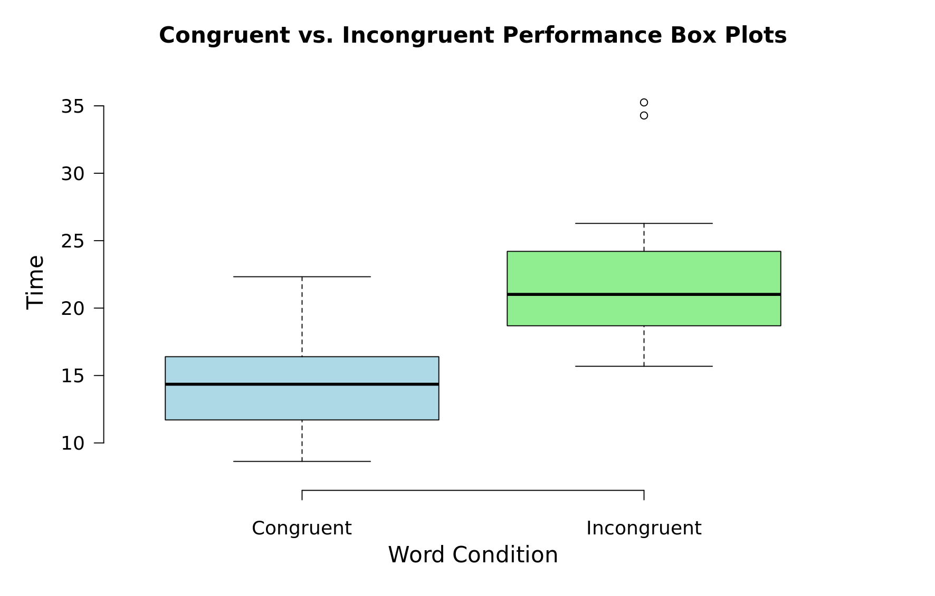
   2. 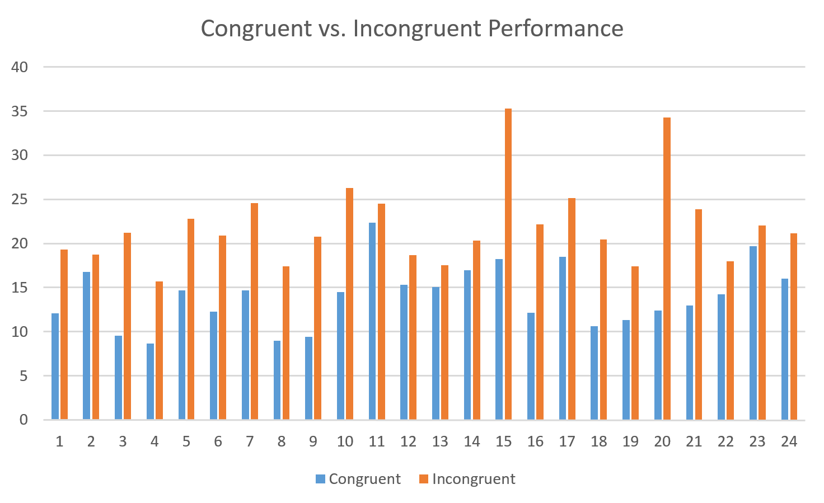
   3. Observations:
      1. In the first visualization, the box plots make it easy to see that the participants tended to take longer to complete the task with the incongruent word condition versus the congruent word condition. You can also see that there are a couple of outliers marked on the incongruent sample data.
      2. In the second visualization, you can easily see that, in every instance, it took the participants longer to name the ink colors during the incongruent word condition versus the congruent word condition.
3. Now, perform the statistical test and report your results. What is your confidence level and your critical statistic value? Do you reject the null hypothesis or fail to reject it? Come to a conclusion in terms of the experiment task. Did the results match up with your expectations?
   1. Confidence level on the mean difference is 95%, t-critical = -1.714.
   2. Conclusion: We should reject the null hypothesis. It took the participants a significantly longer time (t(23) = -8.021, p < .0001) to complete the exercise under the incongruent work condition (M = 22.016, SD = 4.797) versus the congruent word condition (M = 14.051, SD = 3.559). Yes, the results matched my expectations.
4. Optional: What do you think is responsible for the effects observed? Can you think of an alternative or similar task that would result in a similar effect? Some research about the problem will be helpful for thinking about these two questions!

**References:**

* <https://en.wikipedia.org/wiki/Stroop_effect>
* <https://s3.amazonaws.com/udacity-hosted-downloads/t-table.jpg>
* <http://www.graphpad.com/quickcalcs/pValue2/>
* <http://www.statisticshowto.com/when-to-use-a-t-score-vs-z-score/>
* <http://support.minitab.com/en-us/minitab/17/topic-library/basic-statistics-and-graphs/hypothesis-tests/tests-of-means/types-of-t-tests/>
* <http://support.minitab.com/en-us/minitab/17/topic-library/basic-statistics-and-graphs/hypothesis-tests/basics/directional-and-nondirectional-hypotheses/>
* <https://en.wikipedia.org/wiki/Student%27s_t-test#Unpaired_and_paired_two-sample_t-tests>
* <https://www.getdatajoy.com/examples/python-plots/box-plots>
* <http://matplotlib.org/api/pyplot_api.html>
* <http://boxplot.tyerslab.com/>